Sr. No. | Particulars | Data / Information to be filled |  |  | Photo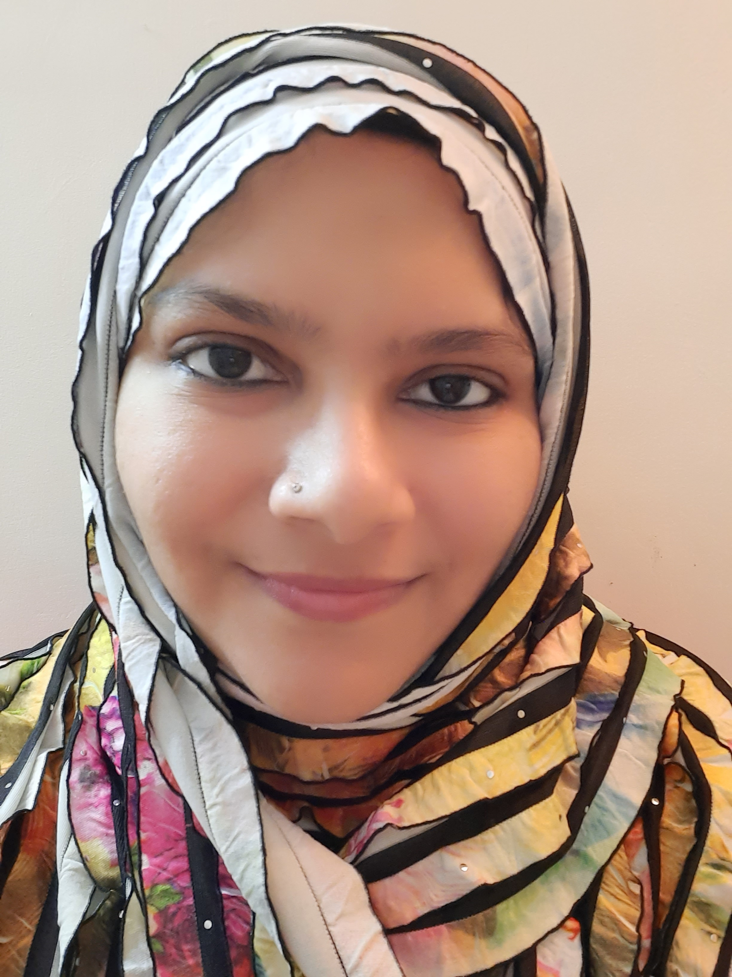
1 | Name of Teaching Staff | Lal Maria Ahmed
2 | Designation | Assistant Professor
3 | Department / School | School of pharmacy
4 | Date of joining. | 1/7/2014
5 | Qualifications with Class / Grade | UG | PG | DOCTORAL
 |  | Distinction | Distinction
6 | Total Experience in Years | Teaching | Industry
 |  | 6.8 yrs
7 | Papers Published (No.) | National | International
 |  | 1 | 2
8 | Papers Presented in Conferences (No.) | National | International
 |  | 4 | 2
9 | PhD Guide ? Give field & University (No.) | Field | University
10 | PhD / Projects Guided (No.) | Ph.D | Projects at Masters Level
11 | Books Published / IPRs / Patents
12 | Professional Memberships | ISTE,CRS
13 | Consultancy Activities
14 | Awards | Best teacher award by Anjuman I Islam ,3rd state level merit ranker at MAH-MPH CET
15 | Grants fetched | Mumbai university minor research projects, AICTE scholarship at M.Pharm
16 | Interaction with Professional Institutions
Note: Attach details wherever necessary

